INVITATION
IEA-EBC Annex 73: Towards Net Zero Energy Resilient Public Communities
First preparation phase experts meeting and a Workshop
April 24-26, 2017
Copenhagen, Denmark

To: Annex 73 experts

Dear Colleagues,

The first preparation phase Annex 73 experts meeting and a workshop will take place in Copenhagen, Denmark on April 24-26, 2017 hosted by the Ramboll Company.
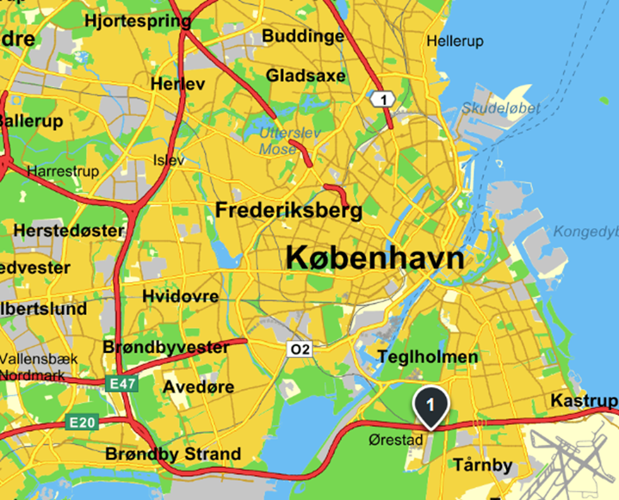
Meeting place: The meeting will take place at Ramboll Company, Ramboll, Hannemanns Alle 53, 2300 Copenhagen S, Denmark, located next to Ørestad reginal train station, 2 stops from the airport and has a metro line connection to the city centre.

Hotel: We recommend to stay at the Crowne Plaza hotel located next to the Ramboll office building. Please book your hotel on-line at: https://www.ihg.com/crowneplaza/hotels/us/en/ copenhagen/rkecp/hoteldetail

.
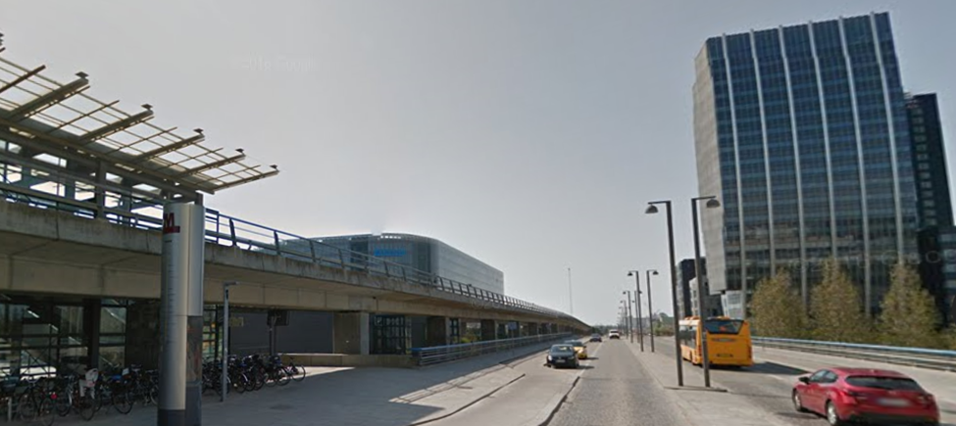
Transport from CPH airport to the Crowne Plaza and Ramboll: Take the regional train towards Copenhagen Central from the underground station in arrival terminal 3 and get off at Ørestad station (2 stops from the airport).
Take the metro line from the airport station 1st floor in terminal 3, in case you want a hotel in the city center near Kgs Nytorv.
By taxi: There is a taxi stand in front of the airport exit.

The experts meeting and the Workshop will take place at the Ramboll Company. Courtesy of Danish industry partners, participation in the experts’ meeting and the workshop will be free of charge.

Registration: To register for the meeting please fill-in attached form and send it not later than 8 April to the address given on the next page.

If you have any questions about the logistics, please don’t hesitate to contact Anders Dyrelund, email: AD@Ramboll.com

Looking forward to seeing you all in Copenhagen.

With kind regards,

IEA EBC Program Annex 61 co-operating agents:
Alexander Zhivov and Rüdiger Lohse
IEA-EBC Annex 73: Towards Net Zero Energy Resilient Public Communities
First Preparation Phase Experts Meeting and Workshop
April 24-26, 2017
Copenhagen, Denmark
Location: Ramboll Company, Copenhagen

Preliminary program
April 24, 2017. Annex 73 working meeting
8:30 | Introductions
8:45 | Alexander Zhivov/Rüdiger Lohse | Opening remarks and objectives for the meeting
9:15 – 10:45 | Task A | Energy Targets (except for Resilience)
 |  | Resilience
 |  | Scope of modeling subtask and methodology to be used
10: 45 | Coffee break
11:00-13:00 | Task B | Case studies: methodologies and potential candidates
13:00 | Lunch at the Ramboll canteen
14:00 -  16:00 | Tasks D and E | Guidance for Net Zero Energy Master Planning
 |  | Develop a functional description of the role of modeling tools in the Net Zero Energy Master Planning Process.
16:00-17:00 | List of things to do A-F (w/o Tasks C and E)
Evening on your own
April 25, 2017 Workshop
Time | Speaker | Topic
08.15–09.00 | Registration
09.00 | Opening remarks | Anders Dyrelund, Ramboll
9:15 | Welcome address | TBD (Energy Agency, local energy authority, MOD, etc)??
09.30 | Overview of the IEA EBC Annex 73 | Alexander Zhivov, ERDC (USA)/Ruediger Lohse (KEA, Germany)
10.00 | Heat Road Map Europe | Brian Vad Mathiesen, AAU, to be confirmed
10.30 | Coffee Break
11.00 | Energy projects for DH&C in cities and campuses in DK and US | TBD, Ramboll
11.30 | DH&C technologies | Sven Verner, Halmstad University, to be confirmed
12.00 | Lunch at the Ramboll canteen
13.00 | State of the art cases for DH&C production and storage for integration of wind | TBD, Ramboll
13.30 | Conversion from steam to DH&C in the Copenhagen Municipality | TBD, HOFOR
14:00 | District heating of the Høvelte and Nymindegab military camps | Jens Peter Sandemand, MOD DK and Jan Olsen, Norfors
14.30 | TBD | IDEA (USA)
15.00 | Coffee Break
15:30 | TBD | AEE (Austria)
16.00 | Exemplary future DH-concept and resulting input parameters for EMP-tools | Stephan Richter, GEF (Germany)
16:30 | Community Resiliency Nodes – Analysis and results of integrated micro or district energy grid concept on community safety and resiliency. | Bobby Jeffers, Sandia National Laboratory (USA)
17:00 | CITIES Strategic Research Centre for IT-intelligent Energy Systems in Cities” and “Energy Lab Nordhavn Full-Scale Smart Energy Lab | Carsten Rode (DTU)
17.25 | Concluding remarks and summary | Alexander Zhivov, ERDC (USA)
17:30-18:00 | Presentations by Industry sponsors
18:00-19:00 | Reception in poster area, networking with sponsors
19.00-22.00 | Dinner and networking
April 26, 2017. Annex 73 working meeting
8:30 | Alexander Zhivov, ERDC (USA)/Ruediger Lohse (KEA, Germany) | Opening remarks
08:45 | Task C | Scenarios
 |  | Modeling tools for district systems
10:45 | Coffee Break
11:00 | Task F | Business, legal and financial aspects of Net Zero Energy Master Planning.
11:45-12:15 | Finalizing the proposal
12:15-12:30 | The status of the Annex 73 participation | Registrations  Letters of participation  Potential funding
12:30-12:45 | Website
12:45-13:00 | Alexander Zhivov/Rüdiger Lohse | Assignments and timeline  Closing remarks
13:00-14:00 | Lunch in the Ramboll canteen
14:00-14:30 | Bus transfer to DTU
14:30-16:00 | Presentation of the District Energy Systems at the campus in Lyngby and a technical tour | Anders B. Møller, Operation Manager of the Campuses of The Technical University of Denmark, Lyngby Denmark  http://www.dtu.dk/english/about/campuses/dtu-lyngby-campus
16:30 | Return to Hotel Crowne Plaza

Registration form

IEA-EBC Annex 73: Towards Net Zero Energy Resilient Public Communities
Experts Meeting- Preparation Phase April 24 & 26, 2017
Workshop: April 25, 2017
Copenhagen, Denmark

Please send to: AD@Ramboll.com, Alexander.M.Zhivo@usace.army.mil and Ruediger.Lohse@kea-bw.de

- Participant Full Name______________________________________________________

- Affiliation (organization name in English)_______________________________________

- Position in the Company_______________________________________

- Country_____________________________________________________

- Your contact information:

  - Address:______________________________________________________________________________________________________________________________________
  - Phone:________________________________________________________________
  - Cell:___________________________________________________________________
  - Email: __________________________________________________________________

- I will participate in the Annex 61 meeting in Copenhagen

April 24______YES__________NO
April 25______YES__________NO
April 26 ______YES__________NO

- I will be staying at
  - Crown Plaza Hotel ___________________________________
  - Other hotel (please identify)___________________________________

Signature and date

