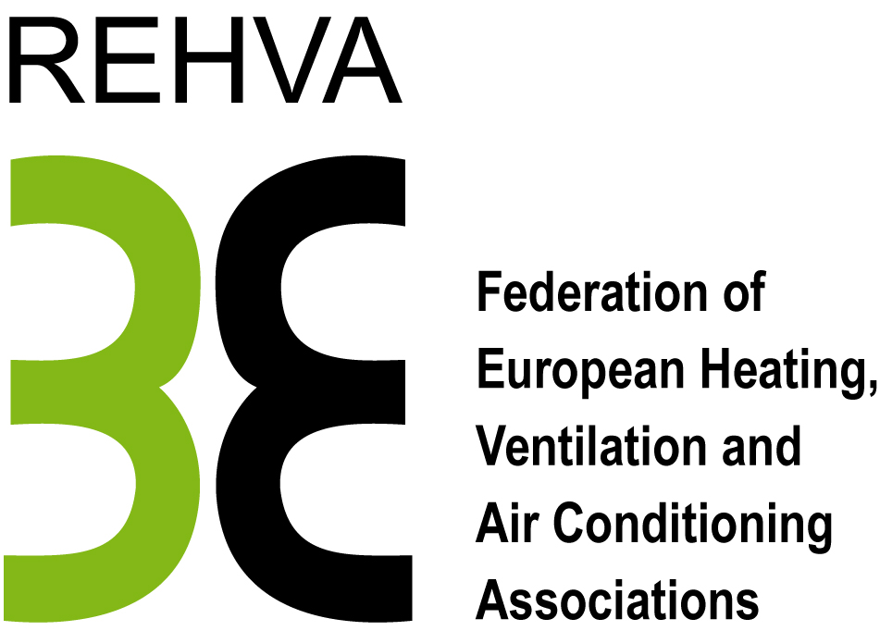
APPLICATION FORM FOR THE AWARDS COMMITTEE

We would like to nominate (*):
Last name: | First name:
Affiliation:

REHVA Award 2017
REHVA Gold Medal | REHVA Professional Award:  Sciences  Design  Technology  Education
REHVA Fellowship
REHVA Young Scientist Award
REHVA Member Association Award
* click where needed

Contact information of the person
who recommend the award-candidate
REHVA Member Association:
Last name: | First name:
Address:
Post/Zip Code: | City:
Country:
E-mail:

Please, return your application form to the REHVA office
before 25 November 2016:
E-mail: info@rehva.eu
Signature of a member of the REHVA member Association: | Date:
(*) Do not forget to join a CV of the nominated candidate

