 | 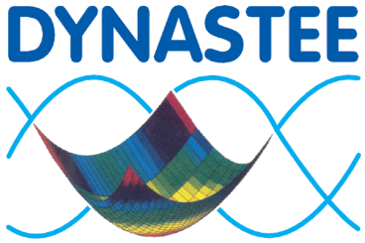 | 

Registration Form

Workshop ‘Building energy performance assessment based
on optimized in-situ measurements’

BBRI Brussels Meeting Center (BBRI), Belgium, 18-19 April 2016

Last name: First name: (Mr/ Mrs/ Dr):
Institution:
Address:

ZIP: City: Country:
Phone: Fax: E-mail:
VAT number:

The workshop package (free of charge) includes:

- The participation to the workshop
- The documentation
- The welcome coffee, coffee breaks and lunches during the workshop

Regarding the dinner organized on Monday 18th April,

○ I would like to receive more information (price, location, …)
○ I am not interested

Please return this completed registration form to Mr. Stéphane Degauquier, Secretariat INIVE EEIG before April 4th
INIVE, Lozenberg 7, BE-1932 St-Stevens-Woluwe, Belgium – Fax : +32.2.653.07.29 – Tel : +32.2.655.77.70 – e-mail : sd@bbri.be

